Product Qualification

--- Compatibility Test ---

Product Name: | SFD25H-M 512GB
Product P/N: | 82.22GG8.3T53C
Firmware Version: | SFPS877A
Description: | SFD25H-M 512GB
Controller: | PS3108-S8
Flash Type: | TH58TEG9DDKBA8H
PCB Version: | FSG0CG1FODM1-ME
Qualification: | Qual FW
Test Result: | Pass

APPROVAL
QT | Date | Signature | Approved by | Date | Signature
Alex Lin | 2015/01/16 | Alex Lin | Danny Chen | 2015/01/16 | Danny Chen
Table Of Content
SUMMARY RESULT 3
A. Function Test With M/B : Gigabyte GA-Z77X-D3H 4
1. Basic Function Test 4
2. Format Test 4
3. Burn In Test 4
4. Reboot Test 4
5. Install System Test 4
6. Test Result 4
B. Function Test With M/B : Asus M4A89GTD PRO USB3 5
1. Basic Function Test 5
2. Format Test 5
3. Burn In Test 5
4. Reboot Test 5
5. Install System Test 5
6. Test Result 5
C. Function Test With M/B : Avalue EMX QM77-A1R 6
1. Basic Function Test 6
2. Format Test 6
3. Burn In Test 6
4. Reboot Test 6
5. Power Failure Test 6
6. Install System Test 6
7. Test Result 6
D. Performance Test With M/B : Asus P8Z77-V PRO 7
E. Performance Test With M/B : Asus Maximus VI Hero 8
F. Platform Compatibility Test 9
G. Additional Qualification: 10
1. Environmental 10
2. Certification 10

SUMMARY RESULT
 |  |  | PC1 |  |  | PC2 |  | PC3 |  |  | PC4 |  |  | PC5
Testing  Product |  |  | SFD25H-M 512GB
System |  |  | Windows 7  Windows 8 |  |  | Windows 7  Windows 8 |  | Windows 7  Fedora 17
M/B | Name |  | GA-Z77X-D3H |  |  | M4A89GTD PRO USB3 |  | EMX QM77-A1R
M/B | Vendor |  | Gigabyte |  |  | Asus |  | Avalue
M/B | Chipset |  | Intel Z77 |  |  | AMD 890GX / SB850 |  | Intel QM77
M/B | Interface |  | SATA III |  |  | SATA III |  | SATS III
M/B | BIOS |  | F16 |  |  | 3207 |  | V1.10
Test Result
Basic Function Test |  |  | V |  |  | V |  | V
Burn  In  Test | Comp32 |  | V |  |  | V |  | V
Burn  In  Test | Iometer  2006.07.27RC3 |  | V |  |  | V |  | V
Burn  In  Test | PassMark  Burn In Test  Pro V6.0.1018 |  | V |  |  | V |  | V
Warm Boot Test |  |  | V |  |  | V |  | V
Cold Boot Test |  |  | -- |  |  | -- |  | V
Power Failure Test |  |  | -- |  |  | -- |  | V
Temp 60℃  Burn In Test |  |  | -- |  |  | -- |  | V
Install System Test
 | Windows  CE | Windows  XP-E |  | Windows  Emb. 7  Standard | Windows  Emb. 8.1  Industry |  | Windows  XP |  | Windows  7 | Windows  8.1 |  | Fedora  17 | Ubuntu  12.04 |  | Red Hat  6.3
Result | V | V |  | V | V |  | V |  | V | V |  | V | V |  | V
Remark:
Test Result — PASS

Function Test With M/B : Gigabyte GA-Z77X-D3H
Testing Product | SFD25H-M 512GB |  |  | Testing Engineer |  | Alex Lin
Testing Environment | M/B: | Gigabyte | Chipset: |  | Intel Z77 |  | BIOS: | F16
Testing Environment |  | GA-Z77X-D3H | Interface: |  | SATA III

Basic Function Test
 | Copy | Delete | Restart | Compare | Suspend  (S3) | Hibernate  (S4) | LED
Win 7 | V | V | V | V | V | V | V
Win 8 | V | V | V | V | V | V | V

Format Test
 | FAT32 | NTFS | exFAT
Win 7 | -- | 476GB | --
Win 8 | -- | 476GB | --

Burn In Test
 | Comp32  15 hours | Iometer(2006.07.27-RC3)  15 hours | Burn In Test V6.0 Pro  48 hours
Win 7 | V | V | V

Reboot Test
 | Warm Boot 2000 Cycles
Win 7 | V

Install System Test
Install System | Result
Install Windows CE System | V
Install Windows XP-E System | V
Install Windows Embedded Standard 7 System | V
Install Windows Embedded 8 Standard System | V
Install Windows Embedded 8.1 Industry Pro System | V
Install Windows XP System | V
Install Windows 7 System | V
Install Windows 8.1 System | V
Install Fedora 17 System | V
Install Ubuntu 12.04 System | V
Install Red Hat 6.3 System | V

Test Result
Pass

Function Test With M/B : Asus M4A89GTD PRO USB3
Testing Product | SFD25H-M 512GB |  |  | Testing Engineer |  | Alex Lin
Testing Environment | M/B: | ASUS | Chipset: |  | AMD 890GX / SB850 |  | BIOS: | 3027
Testing Environment |  | M4A89GTD PRO USB3 | Interface: |  | SATA III

Basic Function Test
 | Copy | Delete | Restart | Compare | Suspend  (S3) | Hibernate  (S4) | LED
Win XP | V | V | V | V | V | V | V
Win 7 | V | V | V | V | V | V | V

Format Test
 | FAT32 | NTFS | exFAT
Win XP | -- | 476GB | --
Win 7 | -- | 476GB | --

Burn In Test
 | Comp32  15 hours | Iometer(2006.07.27-RC3)  15 hours | Burn In Test V6.0 Pro  48 hours
Win XP | V | V | V

Reboot Test
 | Warm Boot 2000 Cycles
Win XP | V

Install System Test
Install System | Result
Install Windows CE System | V
Install Windows XP-E System | V
Install Windows Embedded Standard 7 System | V
Install Windows Embedded 8 Standard System | V
Install Windows Embedded 8.1 Industry Pro System | V
Install Windows XP System | V
Install Windows 7 System | V
Install Windows 8.1 System | V
Install Fedora 17 System | V
Install Ubuntu 12.04 System | V
Install Red Hat 6.3 System | V

Test Result
Pass

Function Test With M/B : Avalue EMX QM77-A1R
Testing Product | SFD25H-M 512GB |  |  | Testing Engineer |  | Alex Lin
Testing Environment | M/B: | Avalue | Chipset: |  | Intel QM77 |  | BIOS: | V1.10
Testing Environment |  | EMX QM77-A1R | Interface: |  | SATA III

Basic Function Test
 | Copy | Delete | Restart | Compare | Suspend  (S3) | Hibernate  (S4) | LED
Win 7 | V | V | V | V | V | V | V
Fedora 17 | V | V | V | V | V | V | V

Format Test
 | FAT32 | NTFS | exFAT
Win 7 | -- | 476GB | --

Burn In Test
 | Comp32  15 hours | Iometer(2006.07.27-RC3)  15 hours | Burn In Test V6.0 Pro  48 hours | Burn In Test V6.0 Pro  Temp 60℃, 48 hours
Win 7 | V | V | V | V

Reboot Test
 | Warm Boot 2000 Cycles | Cold Boot 2000 Cycle
Win 8 | V | V

Power Failure Test
 | 2000 Cycles
Linux | V

Install System Test
Install System | Result
Install Windows CE System | V
Install Windows XP-E System | V
Install Windows Embedded Standard 7 System | V
Install Windows Embedded 8 Standard System | V
Install Windows Embedded 8.1 Industry Pro System | V
Install Windows XP System | V
Install Windows 7 System | V
Install Windows 8.1 System | V
Install Fedora 17 System | V
Install Ubuntu 12.04 System | V
Install Red Hat 6.3 System | V

Test Result
Pass

Performance Test With M/B : Asus P8Z77-V PRO
Testing Product | SFD25H-M 512GB |  |  | Testing Engineer |  | Alex Lin
Testing Environment | M/B: | ASUS | Chipset: |  | Intel Z77 |  | BIOS: | 1206
Testing Environment |  | P8Z77-V PRO | Interface: |  | SATA III
Testing Software | CrystalMark 3.0.2

Performance Before the Test | Performance After the Test
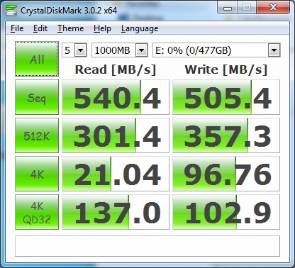 | 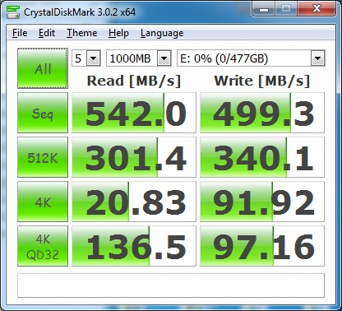

Performance Test With M/B : Asus Maximus VI Hero
Testing Product | SFD25H-M 512GB |  |  | Testing Engineer |  | Alex Lin
Testing Environment | M/B: | ASUS | Chipset: |  | Intel Z87 |  | BIOS: | 0224
Testing Environment |  | Maximus VI Hero | Interface: |  | SATA III
Testing Software | Ubuntu 14.10  Benchmark

Performance Before the Test
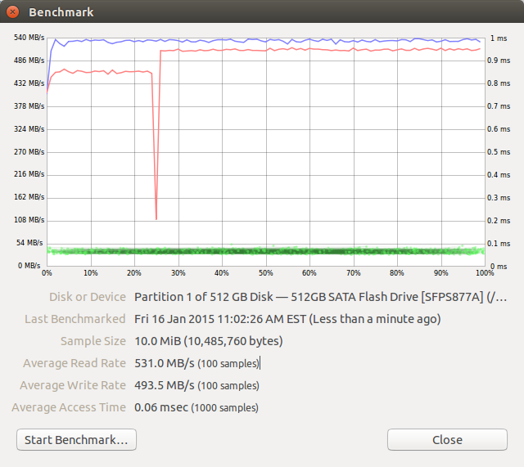

Platform Compatibility Test
Platform Information |  |  |  | Test Item
Chipset | M/B | Interface | System | Format | Copy | Delete | Compare | Restart | Suspend
Intel G35 | Asus P5E-VM HDMI | SATA II | Win7 | V | V | V | V | V | V
Intel P55 | Asus P7P55D | SATA II | Win7 | V | V | V | V | V | V
Intel H67 | Gigabyte PH67A-D3-B3 | SATA II | Win8 | V | V | V | V | V | V
Intel Z68 | Asus P8Z68-M Pro | SATA II | Win8 | V | V | V | V | V | V
Intel Z77 | Gigabyte IVB | SATA II | Win7 | V | V | V | V | V | V
Intel Z77 | Gigabyte IVB | SATA III | Win7 | V | V | V | V | V | V
Intel Z87 | Asus Maximus VI Hero | SATA III | Win8.1 | V | V | V | V | V | V
Intel Z77 | GA-Z77X-D3H | SATA III | Win8 | V | V | V | V | V | V
Intel QM77 | Avalue EMX QM77-A1R | SATA III | Win8 | V | V | V | V | V | V
AMD 780G | Ausu M3A78-EM | SATA II | Win7 | V | V | V | V | V | V
AMD 785G | Asus M4A785D-M Pro | SATA II | Win7 | V | V | V | V | V | V
AMD 790FX | Asus M4A79T Deluxe | SATA II | Win7 | V | V | V | V | V | V
AMD 790GX | Asus M4A78T-E | SATA II | Win8.1 | V | V | V | V | V | V
AMD A88X | Asus A88XM-A | SATA III | Win8.1 | V | V | V | V | V | V

Additional Qualification:

Environmental
- RoHS Standard
- Other Environmental Standard
- WEEE (By Product)
- Battery Standard
- Packing Standard
- Others

Certification
- CE No.
- FCC No.
- BSMI No.
- VCCC No.
- C-tick No.
- Other

