Product Qualification

--- Compatibility Test ---

Product Name: | SFD 25A-M 128GB (ET)
Product P/N:
  APS25A77 (B)128G-8A (B)TM1G (W)
Firmware Version:
  SFDH008A (B)
Controller:
  SCJC72
Qualification: | Qual all
Test Result: | PASS

APPROVAL
QT | Date | Signature | Approved by | Date | Signature
Alex Lin | 2017/06/27 | Alex Lin | Danny Chen | 2017/06/27 | Danny Chen
Table Of Content
SUMMARY RESULT 3
A. Function Test With M/B : ASUS Z170-A 4
1. Basic Function Test 4
2. Format Test 4
3. Burn In Test 4
4. Reboot Test 4
5. Install System Test 4
6. Test Result 4
B. Function Test With M/B : Avalue EMX QM77-A1R 5
1. Basic Function Test 5
2. Install System Test 5
3. Test Result 5
C. Performance Test With M/B : Gigabyte GA-Z77X-D3H 6
D. Performance Test With M/B : Asus Maximus VI Hero 7
E. Platform Compatibility Test 8
F. Additional Qualification: 9
1. Environmental 9
2. Certification 9

SUMMARY RESULT
 |  |  | PC1 |  |  |  | PC2 |  |  | PC3 |  |  |  | PC4
Testing  Product |  |  | SFD 25A-M 128GB
System |  |  | Windows 10 |  |  |  | Fedora  kernel 3.3.4 -5 fc17
M/B | Name |  | Z170-A |  |  |  | QM77-A1R
M/B | Vendor |  | ASUS |  |  |  | Avalue EMX
M/B | Chipset |  | Intel Z170 |  |  |  | Intel QM77
M/B | Interface |  | SATA III |  |  |  | SATA III
M/B | BIOS |  | 2202 |  |  |  | V1.1.0
Test Result
Basic Function Test |  |  | V |  |  |  | V
Burn  In  Test | Comp32 |  | V |  |  |  | --
Burn  In  Test | PassMark  Burn In Test  Pro V8.0 |  | V |  |  |  | --
Burn  In  Test | PassMark  Burn In Test  Pro V3.0.1007 |  | -- |  |  |  | --
Warm Boot Test |  |  | V |  |  |  | --
Cold Boot Test |  |  | V |  |  |  | --
 |  |  | -- |  |  |  | --
 |  |  | -- |  |  |  | --
Install System Test
 | Windows  Emb. 7  Standard | Windows  Emb. 8  Standard |  | Windows  Emb. 8.1  Industry | Windows  10 | Fedora  kernel 3.3.4 -5 fc17 |  | Ubuntu  kernel  3.13.0 -32 | Red Hat  kernel  2.6.32 -431.e16
Result | V | V |  | V | V | V |  | V | V
Remark:
Test Result — PASS

Function Test With M/B : ASUS Z170-A
Testing Product | SFD 25A-M 128GB |  |  | Testing Engineer |  | Alex Lin
Testing Environment | M/B: | ASUS | Chipset: |  | Intel Z170 |  | BIOS: | 1302
Testing Environment |  | Z170-A | Interface: |  | SATA III

Basic Function Test
 | Copy | Delete | Restart | Compare | Suspend  (S3) | Hibernate  (S4) | LED
Windows 10 | V | V | V | V | V | V | V

Format Test
 | FAT32 | NTFS
Windows 10 | -- | 119GB

Burn In Test
Comp32
15 hours
Windows 10 | V

Reboot Test
 | Warm Boot 6000 Cycles | Cold Boot 6000 Cycles
Windows 10 | V | V

Install System Test
Install System | Result
Install Windows Embedded Standard 7 System | V
Install Windows Embedded 8 Standard System | V
Install Windows Embedded 8.1 Industry Pro System | V
Windows 10 Multiple Edition | V
Windows 10 Enterprise | V

Test Result
Pass

Function Test With M/B : Avalue EMX QM77-A1R
Testing Product | SFD 25A-M 128GB |  |  | Testing Engineer |  | Alex Lin
Testing Environment | M/B: | Avalue | Chipset: |  | Intel QM77 |  | BIOS: | V1.1.0
Testing Environment |  | EMX QM77-A1R | Interface: |  | SATA III

Basic Function Test
 | Copy | Delete | Restart | Compare | Suspend  (S3) | Hibernate  (S4) | LED
Fedora  kernel 3.3.4 -5 fc17 | V | V | V | V | V | V | V

Install System Test
Install System | Result
Install Windows Embedded Standard 7 System | V
Install Windows Embedded 8 Standard System | V
Install Windows Embedded 8.1 Industry Pro System | V
Install Windows 7 System | V
Install Windows 8.1 System | V
Install Fedora kernel 3.3.4 -5 System | V
Install Ubuntu kernel 3.13.0 -32 System | V
Install Red Hat Kernel 2.6.32 -431.e16 System | V

Test Result
Pass

Performance Test With M/B : Gigabyte GA-Z77X-D3H
Testing Product | SFD 25A-M 128GB |  |  | Testing Engineer |  | Alex Lin
Testing Environment | M/B: | Gigabyte | Chipset: |  | Intel Z77 |  | BIOS: | F16
Testing Environment |  | GA-Z77X-D3H | Interface: |  | SATA III
Testing Software | CrystalMark 5.0.2

Test Function : BurnIn Test 168hrs
Before | After
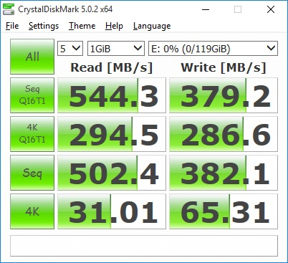 | 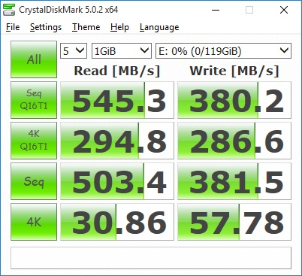

Performance Test With M/B : Asus Maximus VI Hero
Testing Product | SFD 25A-M 128GB |  |  | Testing Engineer |  | Alex Lin
Testing Environment | M/B: | ASUS | Chipset: |  | Intel Z87 |  | BIOS: | 0224
Testing Environment |  | Maximus VI Hero | Interface: |  | SATA III
Testing Software | Ubuntu 14.10  Benchmark

Performance Before the Test
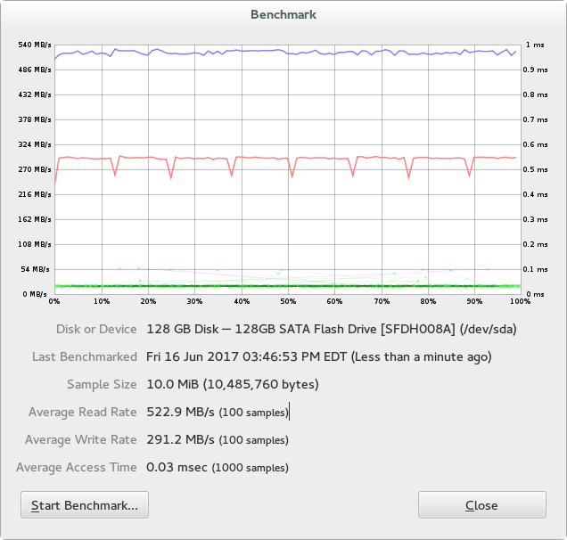

Platform Compatibility Test
Platform | Chipset | M/B | Interface | System | Result
PC1 | Intel Z68 | Asus P8Z68-M Pro | SATA III | Win8.1 | V
PC2 | Intel Z77 | Gigabyte IVB | SATA III | Win8.1 | V
PC3 | Intel Z87 | Asus Maximus VI Hero | SATA III | Win8.1 | V
PC4 | Intel Z77 | GA-Z77X-D3H | SATA III | Win8.1 | V
PC5 | Intel QM77 | Avalue EMX QM77-A1R | SATA III | Win8.1 | V
PC6 | AMD 790FX | Asus M4A79T Deluxe | SATA III | Win8.1 | V
PC7 | AMD 790GX | Asus M4A78T-E | SATA III | Win8.1 | V
PC8 | AMD A88X | Asus A88XM-A | SATA III | Win8.1 | V

Additional Qualification:

Environmental
- RoHS Standard 2011/65/EU , 2015/863/EU
- Other Environmental Standard EC/1907/2006
- WEEE (By Product) 2012/19/EU
- Battery Standard N/A
- Packing Standard 94/62/EC
- Others N/A

Certification
- CE No.
- FCC No.
- BSMI No.
- VCCC No.
- C-tick No.
- Other

